WAR MEMORIALS
IN
ELIE & EARLSFERRY

THE GREAT WAR 1914-18
&

SECOND WORLD WAR 1939-1945

WE WILL REMEMBER THEM

ALAN PROVAN

I have attempted to ensure the accuracy of all the information contained in this publication. If there are any mistakes that offend, then I apologise.

Due to the unavailability of the archives of the period I am unable to confirm that some of the names, on the Golf House Club Memorial, are those I have researched and included in this publication.

This publication and all images © 2011 Alan Provan

ELIE & EARLSFERRY WAR MEMORIAL

At a meeting of Elie Town Council on the 6th December 1918 Provost Miller said that now the war was over it was the duty of the Council to make arrangements for a Memorial "to those connected to this Burgh who had fallen in the War". It was decided that a Committee be formed with powers to add to their number and to proceed at once with raising the necessary funds. The Parish Council and the School Board would be asked for their co­ operation. The Clerk was asked to apply to the War Office for two of the captured German guns and also smaller torpedoes to be placed either side of the Memorial. One idea proposed was for a Memorial Cross at the west end of the Toll Green, another was for Memorial Gates at the entrance to the Parish Church. The Provost said that until it was known how much money would be raised it was too early to choose the type or position of the Memorial. He then read out a list of names he proposed to be remembered.

At a meeting on the 23rd December, consisting of representatives of Elie Town Council, Earlsferry Town Council, The School Board and The Parish Council, it was decided that the Memorial would be a Parish one rather than a Burgh one and circulars would be sent to all ratepayers asking for subscriptions. The Committee would meet again early in the new year to discuss plans and receive a report from Earlsferry Town Council.

At a meeting of Earlsferry Town Council on the 14th January 1919 Provost Cumming reported on the meeting, he had attended on the 6th December and the proposal for the Memorial to be for Elie Parish and not a separate memorial for Elie and Earlsferry. The Council agreed to this proposal.

On the 7th February The War Memorial Committee reported that this week they had issued circulars of appeal to the public asking for contributions. A target of £400 was agreed on. They also said that they would welcome suggestions as to what form the Memorial should take.

By the 19th March a total of £170 had been raised. In early May the Committee decided that a public meeting be held in Earlsferry Town Hall on the 14th to advance matters and to discuss ways to increase the funds already raised. Further meetings were held in May to discuss which type of Memorial would be decided on and where it would be sited.

On the 19th May one captured German gun arrived in the village; this was the one requested by Earlsferry Town Council, and it was placed on the Chapel Green. In 1927 the Council decided it was time to sell it and in October 1928 it was sold to Mr Isaac Newlands for 10/- for scrap, where it stood.

A Committee meeting of July 1919 agreed to ask Mr Harold Tarbolton, Edinburgh to be the architect in advising the Committee. On 10th September Mr Tarbolton proposed the site and design of the Memorial, where it now stands, this was accepted by the Committee, and he was asked to prepare a drawing. At a meeting in October the Committee selected the inscription for the Memorial and it was agreed to donate a sum of money towards the Memorial Tablet to be erected in Earlsferry Town Hall. In December the drawings and costing were received from Mr Tarbolton. It was agreed to write back requiring him to use less land and also to reduce the cost.

At a Public Meeting held on 12th of January 1920 it was discussed and agreed, by a large majority, that name, occupation, rank and regiment of those remembered be put on the Memorial. The design and position, as proposed, was also agreed by the meeting. Steps to be taken to approach the Church to acquire the land needed at the site.

A sale of work and a concert in Earlsferry Town Hall and other fund-raising activities took place throughout the year and carried on into 1921. In October Mr Tarbolton was asked to obtain estimates from local builders and in November the list of estimates was received. It was decided to go for stone tablets instead of bronze and agreed that more circulars to raise more funds be issued. R Pert of Montrose was chosen, his was the lowest bid, as the contractor. [there were no Elie or Earlsferry builders on the list] The total cost was estimated at £675, with £475 having been raised so far. Fund-raising continued.

Building work commenced in early April 1921 and it was reported in the local paper "while the workmen were removing the old wall some weird discoveries came to light". Arrangements were well in hand for the unveiling ceremony, and it was decided, barring delays, this would be on Sunday 24th April. Mr & Mrs Baird, Elie House, said that they were very sorry, but they were unable to attend the Unveiling Ceremony.

In September the final cost of the Memorial was £648 3/- 10d. There was deficit in the Memorial Fund and the two Town Councils agreed that they would make up the deficit, Elie paying half and Earlsferry half as was the normal procedure in joint ventures involving the two Councils.

The list of names read out at the unveiling ceremony and also the list of names proposed by Provost Miller at the meeting on the 6th December are not the names that are on the Memorial now. On close inspection of the Memorial, it can be seen where two alterations and two additions have been carried since the original inscriptions were made.
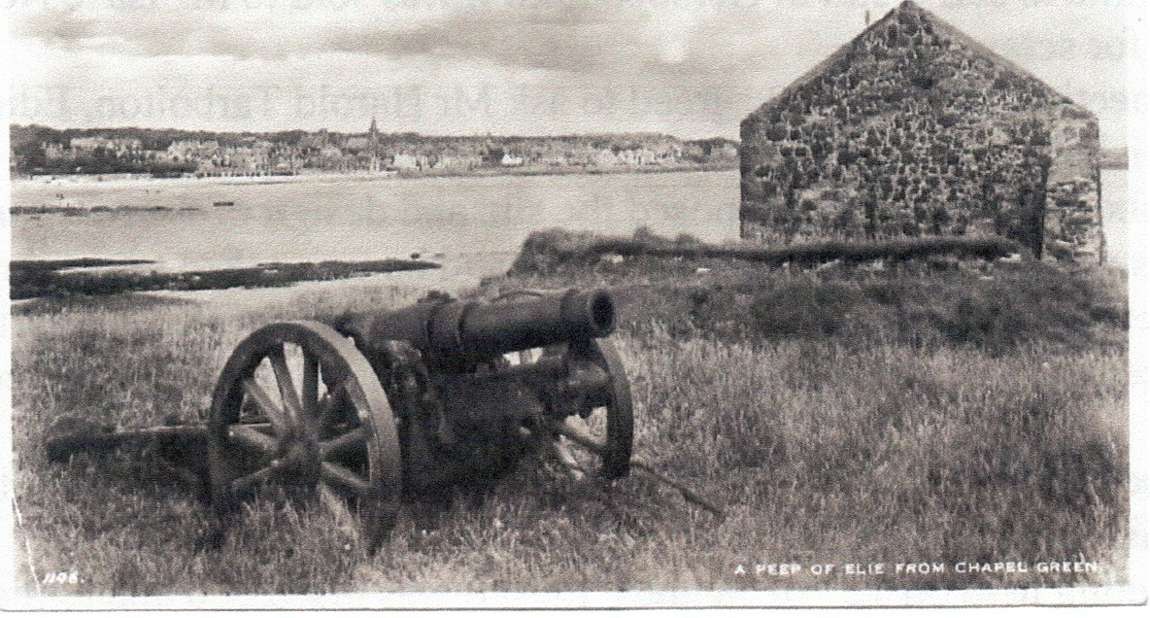

The captured German gun obtained by Earlsferry Town Council.
A Heavy Howitzer 150mm sFH02
ELIE and EARLSFERRY WAR MEMORIAL

UNVEILING CEREMONY 24 APRIL 1921
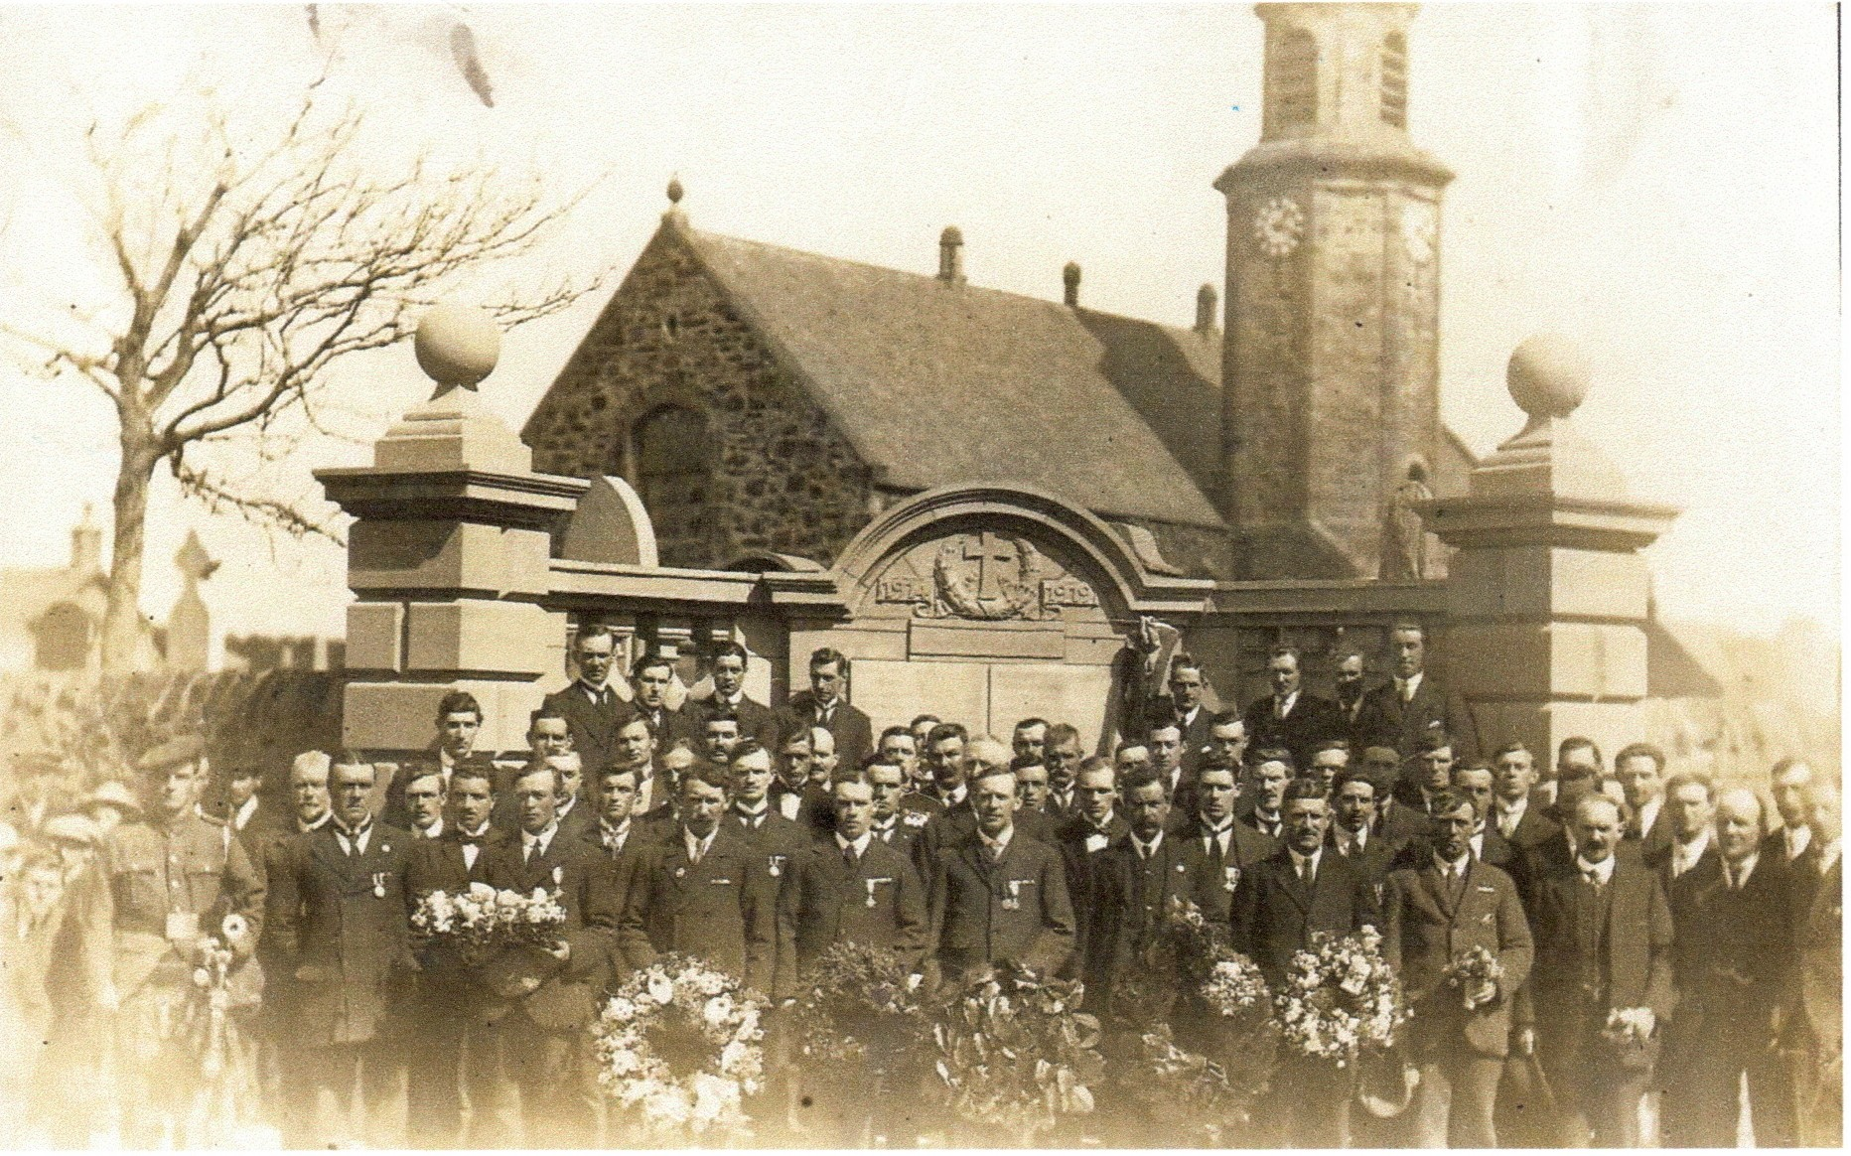

“A most impressive scene was witnessed on Sabbath immediately after the forenoon service, when the Memorial Tablet for our fallen heroes was unveiled in the presence of a large and solemn assemblage who came to honour their dead”.

Rev. Mr. Armstrong, Kilconquhar Parish Church, opened the services by prayer for the dedication of the Memorial. Miss E.F. Scott Moncrieff, The Castle, Elie and the late Commandant of the Auxiliary Red Cross Hospital, who was to perform the ceremony of unveiling the Memorial said "We, met here today, can never forget our brave men, who, at the call of our King and Country, willingly offered their services". In tense silence she then unveiled the Memorial to the public eye and placed a laurel wreath at the base. Rev. Mr. McDiarmid, Wood Memorial Church, Elie, read the inscription and names. He then offered a dedicatory prayer. Many other beautiful wreaths were laid on the Memorial.

The central tablets on which the names are inscribed are of Italian marble. The architect is H.O. Tarbolton, Esq., Edinburgh and the contractors were Messrs J. Pert & Son, Montrose.

(East Fife Observer 28 April 1921.)

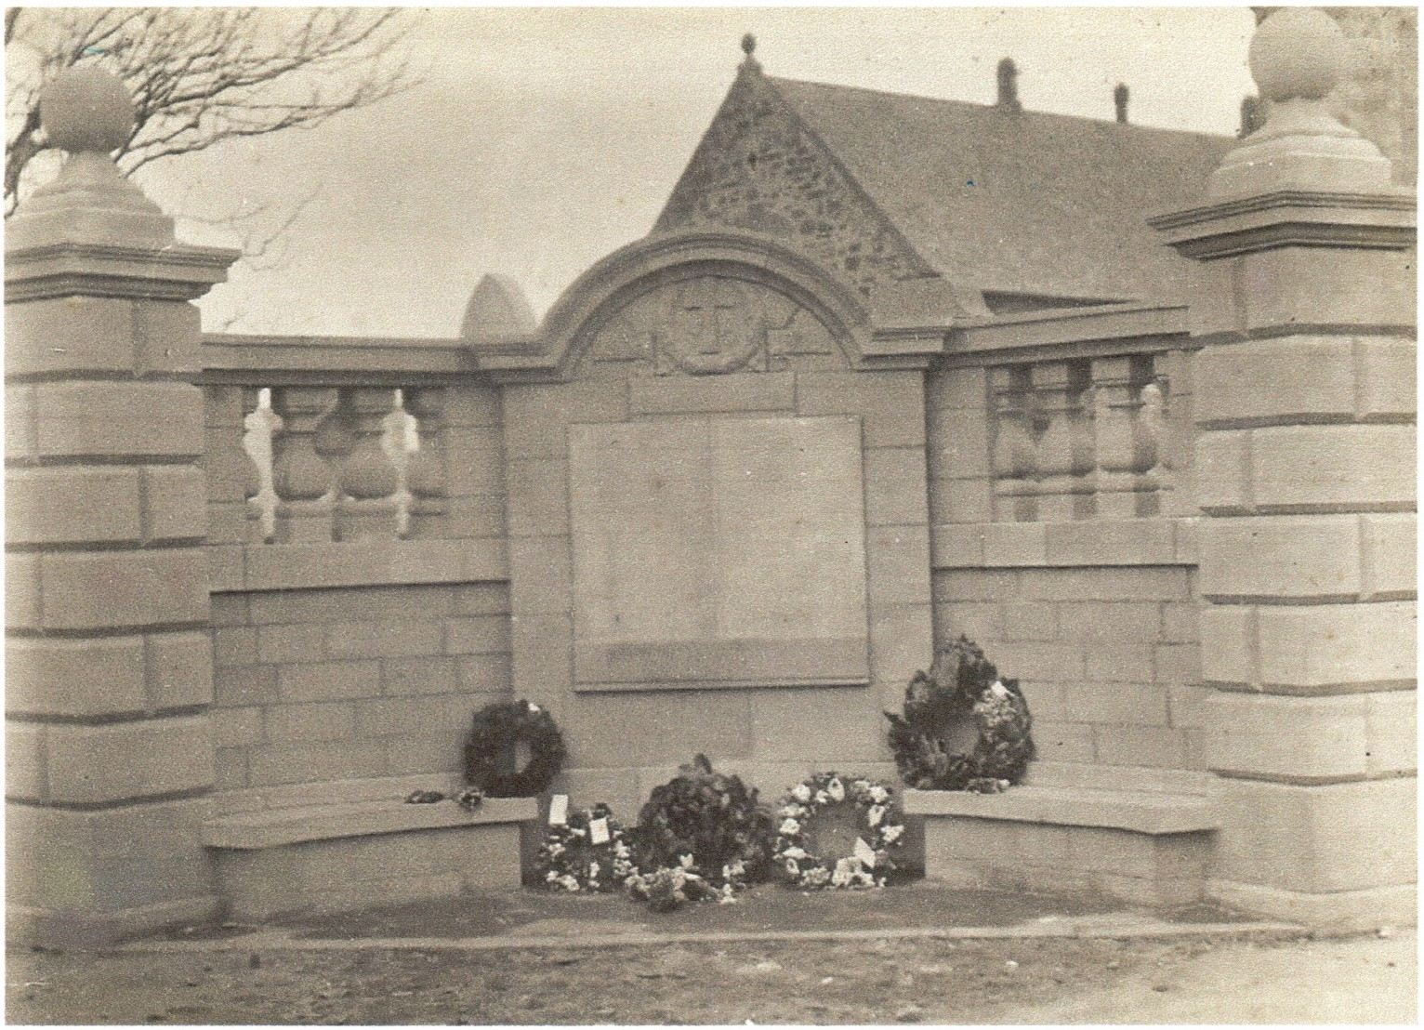

Elie And Earlsferry War Memorial

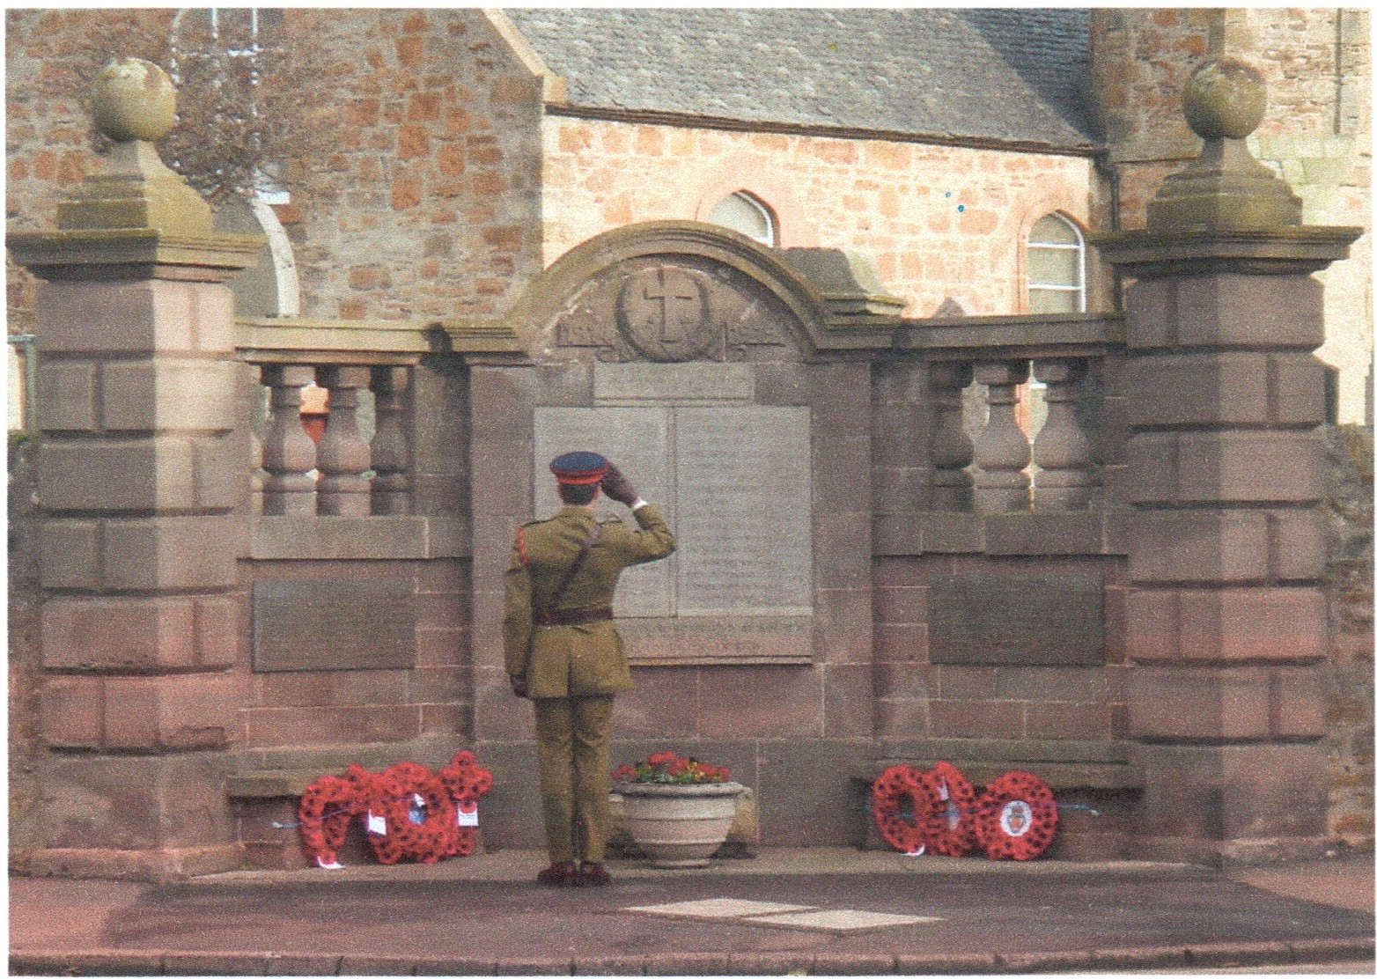

Remembrance Sunday 9 November 2008

ELIE AND EARLSFERRY WAR MEMORIAL
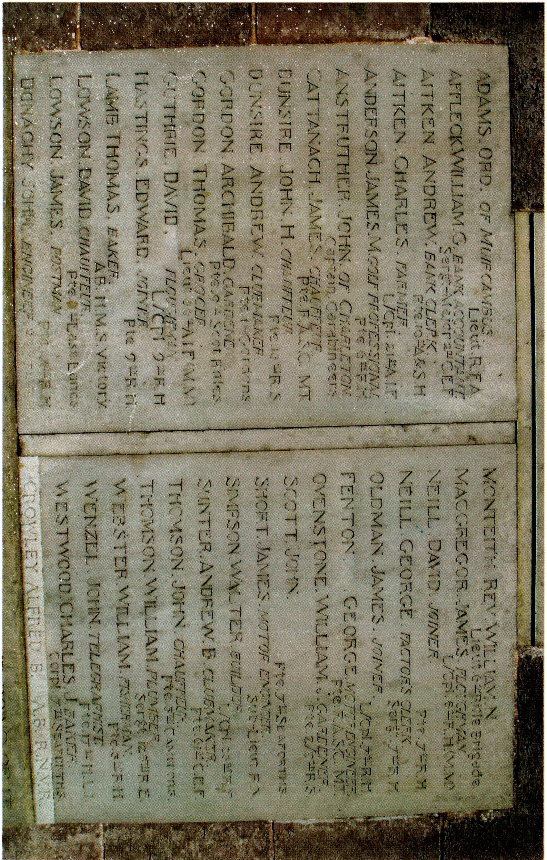
TO THE GLORIOUS MEMORY OF THE MEN FROM
ELIE & EARLSFERRY
WHO FELL IN THE GREAT WAR

Ord Adams
2nd Lieutenant. Royal Field Artillery. Royal Horse and Royal Field Artillery.
b. 28 August 1896. Muircambus. Kilconquhar. 1911 Census Boarding School, Edinburgh.
Son of David Adams and Davida Adams ms Russell m. Inverkeithing April 1894.
Killed in Action age 19. 20 March 1916. Ypres. Remembered Essex Farm Cemetery, Belgium and Kilconquhar Parish Churchyard. Elie Parish Church.
Obituary. East Fife Record. 30 March 1916.
Eldest son of the late Mr Adam, Muircambus. He enlisted in the Fife & Forfar Yeomanry where after some preliminary training he received his commission in the Royal Field Artillery.
Listed in de Ruvigny's Roll of Honour with photograph.

William Given Affleck. Bank Accountant
Private. Canadian Infantry 2nd Bn. (Eastern Ontario Regiment). 7601. Canadian.
b. 24 September 1891 Rankeillor Street, Elie. 1911 Census. Rankeillor Street, Elie. Son of David Affleck [Railway Station Agent] and Isabella Affleck ms Given [Domestic Servant]. m. December 1875. Elie.
Killed in Action 13 September 1917 aged 27.
Remembered. Aix-Noulette Communal Cemetery Extension, France.
Elie Parish Church.
Obituary. Coast Burghs Observer 27 September 1917. see web site - Library and Archives Canada.

Andrew Balfour Aitken. Bank Clerk.
Lance Corporal. Argyll & Sutherland Highlanders. 10th Bn. Service No. S/23177.
b. 5 February 1899 Grange Loan, Edinburgh. 1911 Census 36 Grange Loan. School. Son of John Aitken [Vet] and Jane Aitken ms Stoddart. m. 27 January 1879 Edinburgh. Died of Wounds 3 October 1918.
Remembered. Tincourt New British Cemetery, France.
Earlsferry Town Hall. ex Wood Memorial Church.
Obituary. East Fife Observer 17th October 1918 and 10th October 1918. Son of Mrs John Aitken, Craigview, Earlsferry.

Charles Aitken. Farmer
Private. Australian Infantry. AIF. 21" Bn. Service No. 4971. Australian.
b. 29 January 1895 Grange Loan, Edinburgh. 1911 Census Grange Loan, Edinburgh. Son of John Aitken and Jane Aitken. Brother of Andrew Balfour Aitken.
Died of Wounds 5 October 1918.
Remembered. Ramicourt British Cemetery, France.
Earlsferry Town Hall. ex Wood Memorial Church.
see : www.awm.gov.au/roh

James McKay Anderson. Golf Professional.
Private. Black Watch (Royal Highlanders) 6th Bn. Service No. 265884.
b. 11 February 1882 Williamsburgh. 1901 Census Williamsburgh. Apprentice Mason. Son of Andrew Anderson [fisherman] and Flora Anderson ms McKay.
m. 28 March Inverness.
Husband of Elizabeth Paisley Anderson ms Paisley. m. 12.8.1916 The Manse, Elie. Killed by a bomb 12 August 1918.
Remembered. Roisel Communal Cemetery Extension, France. Elie Parish Church.
East Fife Observer. 25 April 1918 and 5 December 1918.

John Arnold St C Anstruther
Lieutenant. 6th Dragoon Guards Carabiniers. att. 2/Life Guards.
Only son of the late Col Anstruther, DSO., M.V.O. (late Commanding 2nd Life Guards) and of Mrs Anstruther of Charleton, Fife.
A.D.C. to the Gov. Gen: of Australia in 1914.
Last seen wounded at Battle of Zandvoorde died 30 October 1914 aged 25.
Remembered Ypres (Menin Gate) Memorial, Belgium.
Kilconquhar War Memorial. Memorial Plaque Newburn Church, in Largo and Newburn Parish Church.
Fife Herald &Journal 13January 1915.

James Cattanach. Chauffeur.
Private. Army Service Corps. Service No. M2/201922.
b. 24 December 1876 Hazel Hall, Perth Road, Dundee. 1891 Census. Groom. Invergowrie Cottars House.
Son of Peter Cattanach [coachman] of St Helens, Perth Road, Dundee and the late Mrs Sarah Ann Cattanach ms Stevens : Husband of Elizabeth Smith Cattanach of Fernbank Elie. Married Edinburgh 1902.
Death by accidental drowning Basra 18 March 1917 aged 42. Remembered. Basra Memorial, Iraq.
Elie Parish Church.
Obituary. Coast Burghs Observer 12 April 1917.

Andrew Dunsire. Clubmaker.
Private. Gordon Highlanders. 1st Bn. Se1vice No. S/20505.
b. 16 February 1899. Selina Villa, Earlsferry. 1911 Census German's Wynd, Earlsferry. Son of John Dunsire [gardener] and Wilhelmina Dunsire ms Foote.
m. December 1887, Edinburgh. Brother of John Herd Dunsire.
Died of Wounds 3 April 1918.
Remembered. Etaples Military Cemetery, France. Elie Parish Church. Earlsferry Town Hall.
East Fife Observer 11 April 1918.

John Herd Dunsire. Chauffeur.
Private. Royal Scots 18th Bn. Service No. 25164.
b. 5 February 1888 Williamsburgh, Kilconquhar. 1911 Census German's Wynd. Brother of Andrew Dunsire.
Died 21 February 1918 Selina Villa, Earlsferry. TB. Buried. Kilconquhar Parish Churchyard.
Remembered. Elie Parish Church. Earlsferry Town Hall.

Archibald Lumsden Pentland Smith Gordon. Gardener.
Private. Cameronians (Scottish Rifles). 9th Bn. Service No. 43433.
b. 2 October 1897 Toft Cottages, Elie. 1911 Census The Toft, Elie. School.
Son of Francis Hogg Gordon [assistant forester] and Christina Gordon ms Fowler.
m. March 1886. Elie. Brother of Thomas Fowler Gordon.
Died of Wounds 7 April 1917.
Remembered. St Nicholas British Cemetery, France.
Elie Parish Church.
Obituary. Coast Burghs Observer 26 April 1917.

Thomas Fowler Gordon MM. Grocer.
Lieutenant. Australian Infantry A.I.F. 56th Bn. Australian.
b. 29 December 1887 The Toft, Elie. 1911 Census. Lodger. Lothian St, Bonnyrigg. Grocer's Assistant.
Brother of Archibald Gordon.
d. 30 November 1917.
Remembered. Trois Arbres Cemetery Steenwerck, France. Elie Parish Church.
Obituary. Coast Burghs Observer 13 December 1917.
Coast Burghs Observer 31 August 1916. Awarded MC for valour and devotion to duty.
Coast Burghs Observer 21 September 1916. Promoted Sgt. to 2nd Lt.
see: www.awm.gov.au/roh

David Reid Guthrie. Ploughman.
Lance Corporal. Black Watch (Royal Highlanders). 9th Bn. Service No. S/ 43078.
b. 21 March 1894. Rumford, Crail. 1911 Census Kincraig 17 Ploughman.
Son of Davina Guthrie [outdoor worker] of Muircambus, Kilconquhar, Fife.
Killed in Action 25 August 1917. Remembered. Tyne Cot Memorial, Belgium.
Obituary. Coast Burghs Observer 13 September 1917.

Edward Murray Hastings. Joiner.
Lance Corporal. Black Watch (Royal Highlanders). 9th Bn. Service No. S/14145.
b. 8 October 1897 4 High Street, Elie. 1911 Census. 4 High St. School. Son of James Hastings [Groom] and Maggie Hastings ms Adamson.
m. February 1879 Dundee. Killed in Action 9 April 1917.
Remembered. Cabaret-Rouge British Cemetery, Souchez, France. Elie Parish Church.
Obituary. Coast Burghs Observer 26 April 1917.
Coast Burghs Observer 3 May 1917.

Thomas Lamb. Baker.
Able Seaman. Royal Naval Volunteer Reserve. Service No. Clyde Z/7611.
b. 4 October 1882 Dumbiedykes Road, Edinburgh. 1901 Census 5 Park Place, Elie. Son of Frederick Lamb [Railway Guard] and Mary Lamb ms Winterbottom.
m. June 1880. Edinburgh.
Died 5 South Street, Elie 22 November 1918. Aged 36. [cause unreadable]. Buried. Elie Parish Churchyard. Remembered. ex Wood Memorial Church. East Fife Observer 28 November 1918.

David Millar Lowson. Chauffeur.
Private. East Lancashire Regiment. 6th Bn. Service No. 7319.
b. 24 June 1877. Parish of Forgan. 1891 Census. High Street, Newport. Parish of Forgan. Son of James Lowson [ploughman] and Agnes Lowson ms Miller, fourth son of Mrs Lowson, Stenton Row, Elie.
m. June 1863 Parish of Arbirlot. Brother of James Lowson.
Died of dysentery Mesopotamia 12 July 1916.
Remembered. Kirkee 1914-1918 Memorial, India.
Elie Parish Church.
Obituary. East Fife Record 27 July 1916.
Coast Burghs Observer 27 July 1916. Formerly 10th/18th Hussars, served in the Boer War, where he received two medals and several clasps.

James Lowson. Postman.
Private. Black Watch (Royal Highlanders). 7th Bn. Service No. 290441.
b. 6 September 1885 Parish of Forgan. Brother of David Lowson. 1911 Census. 26 Bank St. [with parents] 25. Bakery van driver. Died of wounds in hospital 24 April 1917 aged 31.
Remembered. Aubigny Communal Cemetery Extension, France.
Elie Parish Church.
Obituary. Coast Burghs Observer 3 May 1917.

John Bernard Donaghy. Engineer.
Private. Black Watch (Royal Highlanders). 7th Bn. Service No. 290474.
b. 26 May 1897 Shore Road, Anstruther. 1911 Census Visitor. St Ronans, Williamsburgh. School. 13.
Son of James Donaghy [General Labourer] and Agnes Donaghy ms Robb. 2 Allan Place, Earlsferry.
m. November 1886 Anstruther Wester. Died of Wounds 24April 1917.
Remembered. Duisans British Cemetery, Etrun, France.
Elie Parish Church. Earlsferry Town Hall.

Rev William Neve Monteith.
Lieutenant. Rifle Brigade. 6th Bn. (attached 2nd Bn.).
b. 28 August 1878 The Manse, Parish of Glencairn. 1901 Parish of Glencairn. Son of John Monteith [Minister of Glencairn Parish] and Ellon Maria Monteith ms Neve. m. July 1874 Kent.
1911 Census. Established Church Manse, High St, Elie. 32. Minister [C of S].
m. 30 March 1915. Muriel May. Largo parish Church. Killed in Action at Loos 25 September 1915.
Remembered. Ploegsteert Memorial, Belgium. St Giles Cathedral, Edinburgh. Memorial Plaque Elie Parish Church. Golf House Club, Elie.
Minister of Elie Parish Church from 1907 till he volunteered at outbreak of war 1914. Obituary. East of Fife Record 7 October & 14 October 1915.
see : www.roll-of-honour.com/Dumfriesshire/Moniave
see: Elie Parish Church Guild publication Rev. W.N. Monteith. by Jim Bell.

James Macgregor MM. Ploughman.
Lance Corporal. Black Watch (Royal Highlanders). C Coy. 8th Bn. Service No. S/11338.
b. 16 December 1897 Kilminning Out Houses, Parish of Crail.
1911 Census. Ardross, Elie. 13. School.
Son of Robert Clink Macgregor [Ploughman] and Isabella Macgregor ms Nicholson.
m. December 1897 Logie, Fife. Killed in Action 3 May 1917.
Remembered. Arras Memorial, France.
Elie Parish Church.
Son of Robert & Isabella McGregor of Bankhead, Piteadie, Kirkcaldy.

David Christie Neill. Joiner.
Private. Black Watch (Royal Highlanders). 7th Bn. Service No. 290437.
b. 20 May 1898 Ferry Lodge, Earlsferry. 1901 Census. German's Wynd, Earlsferry. Son of William Neill [Tailor & Clothier] and Catherine Neill ms Christie.
m. December 1895 Elie. Nephew of George Bond Neill.
Died of disease when a Prisoner of War 1 July 1918. Remembered. Niederxwehren, Germany.
Earlsferry Town Hall. ex Wood Memorial Church.
East Fife Observer. 19 December 1918. Obituary. East Fife Observer 21 February 1919.

George Bond Neill. Factor's Clerk.
Serjeant. Black Watch (Royal Highlanders) 6th Bn. Service No. 290024.
b. 7 December 1887 Shore, Crail. 1911 Census. Russell Cottage, The Terrace. Assistant Factor. Wife Margaret b. Oban. m. 4 November 1910 The Police Station, Dalmally. Margaret McCuish Mclsaac 24. School Teacher. Residence Elie.
Son of John Neill [Gas Maker] and Marjory Neill ms Scott m. May 1866 Crail.
Uncle of David Christie Neill.
Killed in Action 21 March 1918.
Remembered. Arras Memorial, France. ex Wood Memorial Church. Obituary. East Fife Observer 18 April 1918.

James William Milne Oldman. Joiner.
Lance Corporal. Black Watch (Royal Highlanders). 7th Bn. Service No. 290436.
b. 27 January 1898 Errol Station, Parish of Errol. 1911 Census Stenton Row, Elie.
Son of George Oldman [Mechanic] and Alexanderina Oldman ms Urquhart
m. September 1895 Edinburgh. Alexanderina died 16 February 1901.
Georgina Oldman ms Urquhart of Lynwood, Elie was his stepmother and his aunt.
d. 26 March 1918.
Remembered. Arras Memorial, France.
Elie Parish Church.

George Rogers Fenton. Motor Engineer.
Private. The Queen's (West Surrey Regiment). Service No. 15454. Formerly. Royal Berks Regiment 1st Bn. Service No. 11065.
b. 5 November 1890 District of Newington, Edinburgh. Son of George Rogers Fenton and Jane Fenton ms Fairfull. m. December 1885 Edinburgh.
1901 Census Dartmouth Road, Selley Oak, Worcestershire. Killed in Action 27 August 1916. Aged 25.
Remembered. Heilly Station Cemetery, Mericourt-L'Abbe, France.
Obituary. East of Fife Record 21 September 1916. George R Fenton eldest son of Mr George Fenton, Hypericum, Elie.
Coast Burghs Observer 21 September 1916.
His name on War Memorial has been altered. Mystery surrounds this soldier and family.

William James Ovenstone. Gardener.
Lance Corporal. Royal Scots (Lothian Regiment). 9th Bn. Service No. 315000.
b. 26 December 1896 2 Links Place, Elie. 1911 Census 1 Links Place, Elie. School.
Son of William Ovenstone [Assistant Postmaster] and Janet Ovenstone ms McGill. m. March 1897 Leith.
Died of Wounds 26 September 1917.
Remembered. Dozinghem Military Cemetery, Belgium.
ex Wood Memorial Church.
Obituary. Coast Burghs Observer 4 October 1917.

James Hassard Short. Motor Engineer. Lieutenant. Royal Naval Reserve.
b. 1888 Beckenham, Kent. 1901 Census High Street, Earlsferry.
Son of John Locke Broadbent Short [Clerk in London Law Courts] and Edith Constance Short.
Drowned at Sea 4 April 1918.
Remembered. Plymouth Naval Memorial, England.
St Michael and All Angels, Elie. Earlsferry Town Hall.
Obituary. East Fife Observer 11 April 1918.Joined the Merchant Navy 1914.
H.M.S. Bittern [C Class destroyer] was sunk in a collision in 1918, collided with SS Kenilworth off Portland Bill. All hands lost.

John Annit Harcus Scott.
Private. Seaforth Highlanders. 7th Bn. Service No. S/24111.
b. 8 May 1899 Williamsburgh, Elie 1911 Census Williamsburgh, Elie. 11. School. Son of Thomas Scott [Carter] and Christina Scott ms Harcus. m. January 1892 Leith.
Died of Wounds at a casualty clearing station, France. 18 April 1918. aged 19.
Remembered. Haringhe (Bandaghem) Military Cemetery, Belgium.
Memorial Elie Parish Church. St Michael and All Angels, Elie. Obituary. East Fife Observer 2 May 1918.

Walter Simpson. Baker.
Lance Corporal. Royal Fusiliers. 23rd Bn. Service No. SPTS/1222.
b. 12 May 1874 Lawhead, Cameron. 1911 Census. Main St, Kilconquhar. Son of John Simpson [Labourer] and Janet Simpson ms Robertson. m. June 1868 Kilconquhar.
Killed in Action by a sniper 1 July 1916.
Remembered. Thiepval Memorial, France.
Elie Parish Church. Earlsferry Town Hall.
m. Margaret Law Herd at Links Cottage, Earlsferry 8 December 1905. Obituary East of Fife Record 10 August 1916.
Had already served in the Boer War.

Andrew Bowie Sunter. Clubmaker.
Private. Canadian Infantry (Manitoba Regiment). Service No. 460920.
b. Andrew Alexander Sunter. 21 March. Liberty Place, Liberty, Elie. Son of Christopher Sunter [Mason] and Robina Sunter ms Thomson. m. 27 July 1867 Kilconquhar.
Killed in Action on the Somme 24 June 1916. Remembered. Railway Dugouts Burial Ground, Belgium.
Memorial Tablet ex Wood Memorial Church as Andrew A Sunter.
Elie War Memorial should read Andrew A Sunter. Andrew B is also correct. Obituary. East of Fife Record 10 August 1916.
Andrew B Sunter his cousin died Edinburgh 1956.

John Main Thomson. Chauffeur.
Lance Corporal. Cameron Highlanders. 5th Bn. Service No. 3/5763.
b. 13June 1885 Toft, Elie 1901 Census The Toft, Elie. Message Boy. Son of William Thomson [Fisherman] and Jessie Thomson ms Main. m. October 1876 Elie.
Brother of William Thomson.
Died 14 October 1916.
Remembered. Thiepval Memorial, France.
ex Wood Memorial Church. Obituary.
East of Fife Record 16 November 1916.

William Thomson. Plumber.
Serjeant. Royal Engineers. 128th Field Coy. Service No. 89555.
b. 27 January 1878 at Toft, Elie. Brother of John Main Thomson.
1911 Census. Links Road, Earlsferry. Plumber.
Died of Wounds 22January 1917 Belgium.
Remembered. Lijssen Thovk Military Cemetery, Belgium.
ex Wood Memorial Church.
Obituary. Coast Burghs Observer 1 February 1917.

William Webster. Fisherman.
Private. Black Watch (Royal Highlanders). 10th Bn. Service No. 13392.
b. 22 October 1877 Earlsferry 1911 Census Germans Wynd, Earlsferry. Fisherman. 33. Son of William Webster [Fisherman] and Ann Webster ms Runcie. m. August 1873 Fraserburgh.
Died of Pneumonia at Salonica 27 February 1917.
Remembered. Sarigol Military Cemetery, Kriston, Greece.
Earlsferry Town Hall.
Obituary. East Fife Observer 14 April 1918.

John Wenzel. Telegraphist.
Private. Highland Light Infantry. 16th Bn. Service Number 30121.
b. 3 December 1884 West Shore, St Monance. Also Reg'd Parish of Largo. Son of Ludwig Wenzel [Butcher] and Margaret Wenzel ms McFarlane. m. November 1883 St Monance.
1901 Census 26 Bank Street, Elie. Assistant in Post Office.
Killed in Action 2 December 1917.
Remembered. Poelcapelle British Cemetery, Belgium.
Elie Churchyard. Memorial Tablet ex Wood Memorial Church, in Elie Parish Church. Earlsferry Town Hall.
Obituary East Fife Observer 24 January 1918. A large article on this man's unfortunate experience in the British Army and his treatment therein.

Charles John Westwood. Baker.
Private. Seaforth Highlanders. 7th Bn. Service No. S/25111.
b. 14 May 1899 West Road, Oakham, Rutland. 1911 Census 37 High St., Elie. School. Living with uncle William Fairweather.
Son of Harry Westwood [Coachman] and Rosina Ann Westwood ms Fairweather.
m. December 1896 37 High Street, Elie. Killed in Action 12 April 1918 aged 19.
Remembered. Tyne Cot Memorial, Belgium.
Memorial Elie Parish Church.
Obituary. East Fife Observer 9 May 1918.
Employed by Messrs Morris & Son Bakers.

Alfred Brown Crowley.
Ordinary Seaman. Royal Naval Volunteer Reserve. Service No. ClydeZ/10038.
b. 18 July 1900 High Street, Earlsferry. 1901 Census Links Road, Earlsferry. 1911 Census Stevenson Drive, Langside, Glasgow. 10. School.·
Son of James Crowley [Golfclub maker] and Margaret Crowley ms Manson.
m. October 1886 Wick.
Son of James and Margaret Crowley of 42 Durward Avenue, Shawlands, Glasgow.
d. Marine Return states RNVR RN Depot Crystal Palace. Cause of Death 3. Death Certificate. died of pneumonia at Minard Road, Glasgow. 7 October 1918.
Buried. Kilconquhar Parish Churchyard
Also remembered. Memorial Plaque, Elie Parish Church. Memorial Tablet Earlsferry Town Hall.
After moves by the Royal Burgh of Earlsferry and Elie Community Council his name was added to Elie War Memorial in 1996.

ELIE PARISH CHURCH
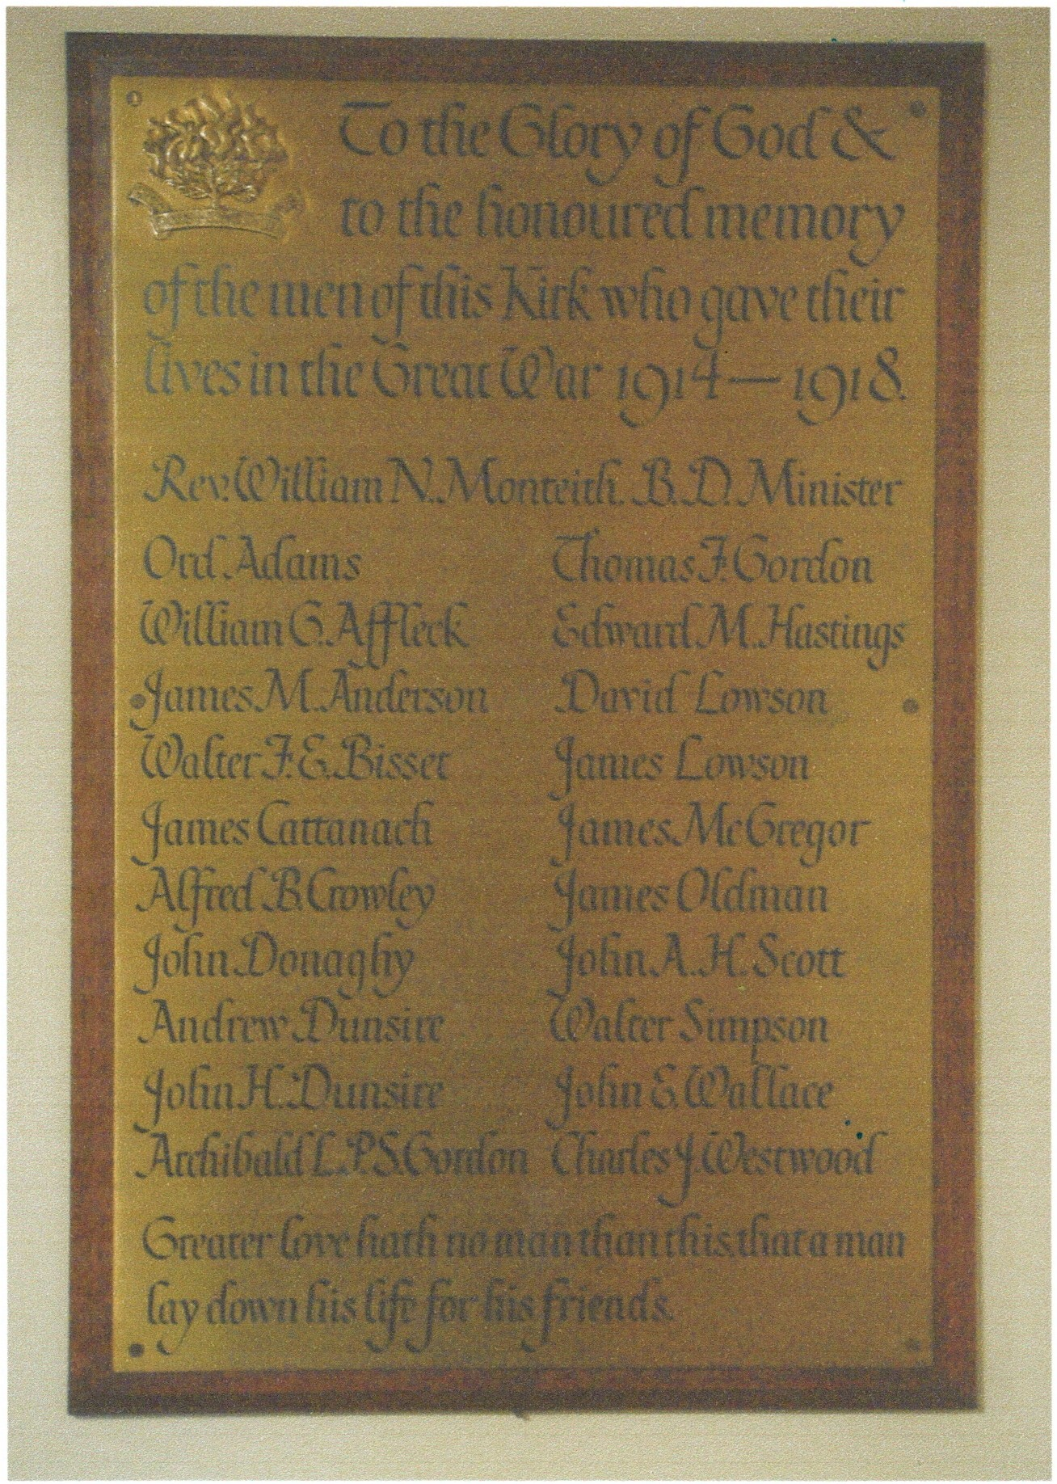
Unveiled and dedicated on 26 February 1922
by the Rev. R.H. Dunlop, Home Mission Deputy.

ELIE PARISH CHURCH

Greater love hath no man than this that a man lay down his life for his friends.

Walter Faviere Edington Bisset.
Second Lieutenant. Gordon Highlanders. "H" Coy. 9th Bn. (Pioneers)
b. 21 February 1889 S. Stoneham, Hampshire. 1891 Census Christchurch. Son of Maurice E Bisset and Anna I E Bisset ms Brinkley. m. 1884 Bath, Avon, Somerset.
1911 Census. Lynwood, High Street, Elie. Boarder. 22. Agricultural Student. Estate Office.
Son of Mrs Erlington-Bisset of Lessendrum, Huntly and the late Major Maurice Erlington- Bisset, late Royal Engineers of Lessendrum. Both parents born in Ireland.
(From Monteith letters he was Best Man at the wedding of Rev. William N Monteith.)
Reported missing 25 September 1915. Hill 70. Battle of Loos.
Remembered. Loos Memorial, France.
Memorial. Golf House Club, Elie. Drumblade War Memorial. Elie Parish Church.

John Ewing Wallace.
Second Lieutenant. Royal Air Force. 107 Sq.
b. 16 August 1899 Shelboume, Nova Scotia.
Son of Rev. John Wallace and Margaret Wallace ms Brown m. 1891 Edinburgh. Mother Mrs Wallace, 10 Mayfield Road, Edinburgh.1911 Census The Manse, Kirriemuir. 11.
Died 9 August 1918. An Observer in an DH9 D5666- seen to go down in flames.
Remembered. Arras Flying Services Memorial, France.
Elie Parish Church
Kirk Session Minutes 22 January 1917: Young communicants put forward for Church Membership - John Ewing Wallace (this is only Elie connection found).

MEMORIAL TABLET ex WOOD MEMORIAL CHURCH

Relocated to West Porch, Elie Parish Church.

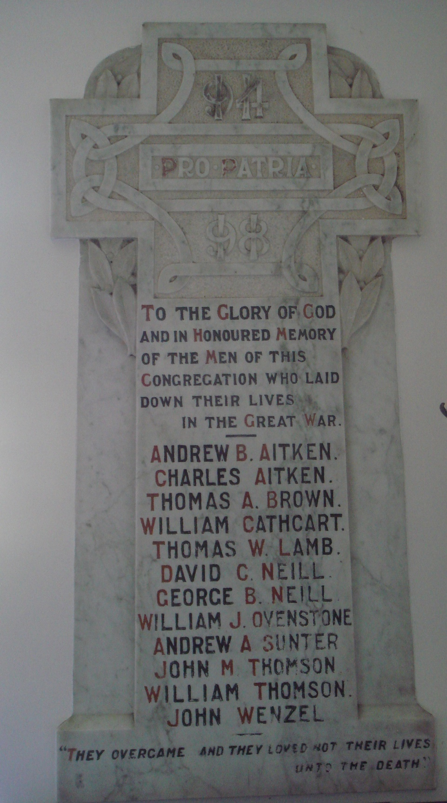

Marble Tablet unveiled on 27 June 1920. Wood Memorial UF. Church
Rev. Mr. McDiarmid gave brief address. Rev. Mr Armstrong, Kilconquhar, carried out the dedication service. Relocated to its present position in Elie Parish Church in 1962.
Architect was H.O. Tarbolton Esq. Edinburgh. Contractor Messrs J. Pert & Son, Montrose.

MEMORIAL TABLET ex WOOD MEMORIAL CHURCH

Relocated to West Porch, Elie Parish Church.
They overcame and they loved not their lives unto the death.

Thomas Alexander Brown.
Captain. Mercantile Marine.
b. 27 December 1868 Earlsferry.
Son of Thos A Brown [Officer Merchant Navy] and Janet Brown ms Duncan.
m. October 1867 Elie.
m. Jane McGill of Fountain Road, Elie at Laburnum Bank, Fountain Road, Elie. 19 Dec 1894.
1911 Census 51 Dudley Avenue, Leith. 42. Shipmaster.
Died presumably of wounds at Areisberg, Russia. 8th August 1917 Master of “ELBA” 109597. On loan to the Russian Government Remembered. Kuresaare Town Cemetery, Estonia. CWGC grave. Obituary. Coast Burghs Observer 23 August 1917.

William Cathcart.
Private. Royal Scots Fusiliers. 1/5th Bn. Service No. 7884.
b. 16 August 1891 Fielden St, Glasgow.
Son of James Cathcart [Labourer] and Susannah Cathcart. 1911 Census Barnyards, Kilconquhar. 18. Gardener.
Killed in Action in the Dardanelles 7 June 1915. Remembered. Pink Farm Cemetery Helles, Turkey.
Obituary. East of Fife Record 8 July 1915.
First soldier from Kilconquhar to be lost in the war. Coast Burghs Observer 1 July 1915.

SCOTTISH EPISCOPAL CHURCH EAST NEUK OF FIFE

SAINT MICHAEL AND ALL ANGELS ELIE

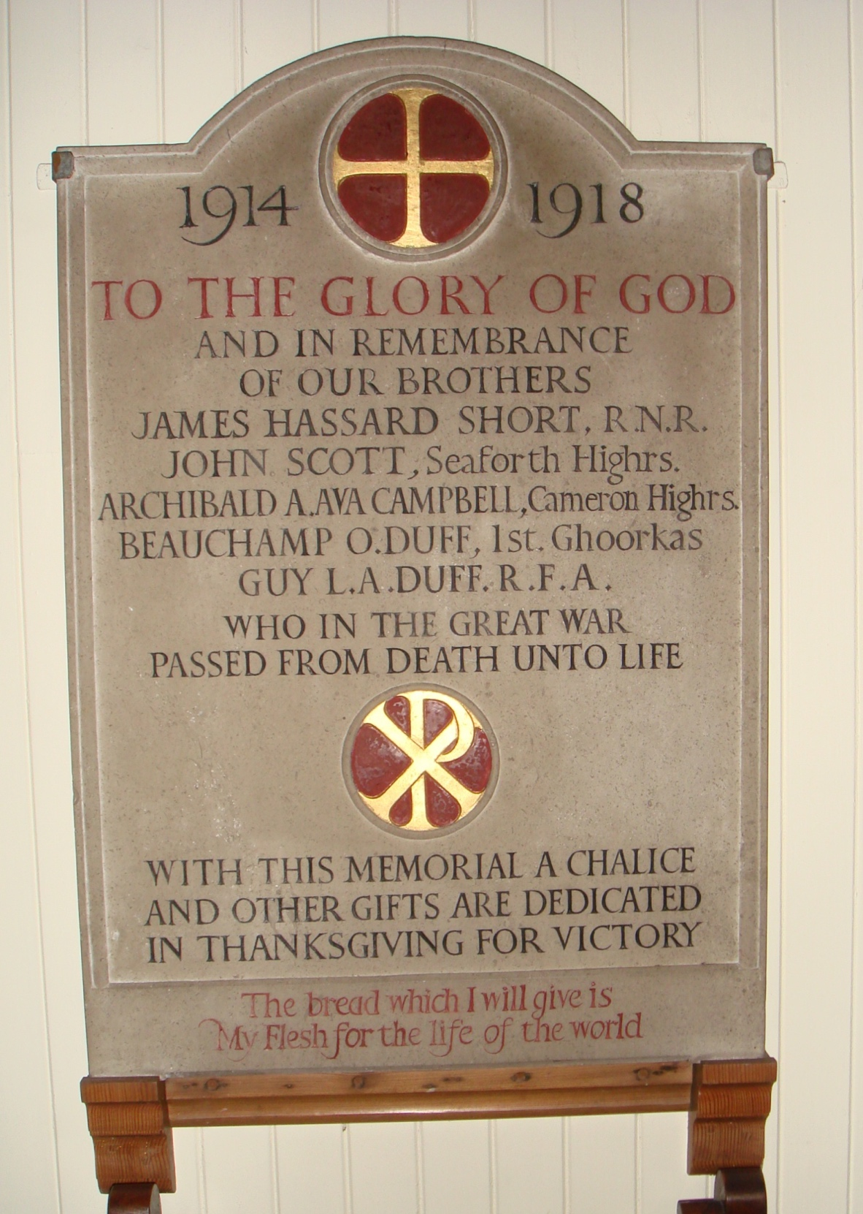

Dedicated in 1920 when the Church stood at Craigforth, Earlsferry.
In 1924, due to the loss of the lease of the land, the structure and all its contents were moved to the present site in Williamsburgh on ground adjoining St. Gabriel's Bield, which had been bequeathed to the church by Canon Bowstead. After being closed for 3 months for the demolition and removal, the Church reopened on the 7th December.

ST MICHAEL AND ALL ANGELS, ELIE.
The bread which I will give is My Flesh for the life of the world.

Sir Archibald Augustus Ava Campbell.
Lieutenant. Cameron Highlanders. 6th Bn.
b. 5 December 1879 Barham Cottages, Monimail. Fife.
Son of Sir Archibald Ava Campbell and Henrietta Ellen Hutton Dawson Campbell. ms Uthwatt. m. January 1876 England.
1901 Census Gibliston Mansion House, Fife.
d. 9 May 1916 aged 38. Shot by a sniper at the Hohenzollern Redoubt, Loos. Remembered. Vermelles British Cemetery, Franee.
Carnbee War Memorial.

Beauchamp Oswald Duff.
Captain. 1st King George's Own Gurkha Rifles (The Malaun Regiment).
b. India c1881. 1891 Census. Dalvreck Academy, Comrie Road, Crieff.
m. March 1908 Hanover Square, London to Mary Lander.
Step Cousin of Guy LA Duff.
Killed in Action 7 November 1914. Remembered. Neuve Chapelle Memorial, France.
Obituary. Coast Burghs Observer 19 November 1914.
Son of the late Gen. Sir Beauchamp Duff, GCB [Commander-in-Chief in India] and Lady Duff. m.1876 Grace Wood.
Served in Waziristan and Somaliland Campaigns (1901-04).
Nephew of Mrs Duff, Elie. Family - Duffs of Hatton Castle, Aberdeenshire.

Guy Leith Assheton Duff.
Captain. Royal Field Artillery. 104 Battery.
b. 1893 Ireland.
Son of Walter Garden Duff and Elizabeth Duff ms Leith. Resident Magistrate at Downpatrick ex Royal Irish Constabulary.
Step Cousin of Beauchamp O Duff. Nephew of Miss ME Duff and Miss Douglas Mary Duff of Chapel Green, Earlsferry.
Died 2 September 1916 London Hospital, Whitechapel. During operation to a gunshot wound.
Buried St Andrews Eastern Cemetery, Scotland.

GOLF HOUSE CLUB ELIE

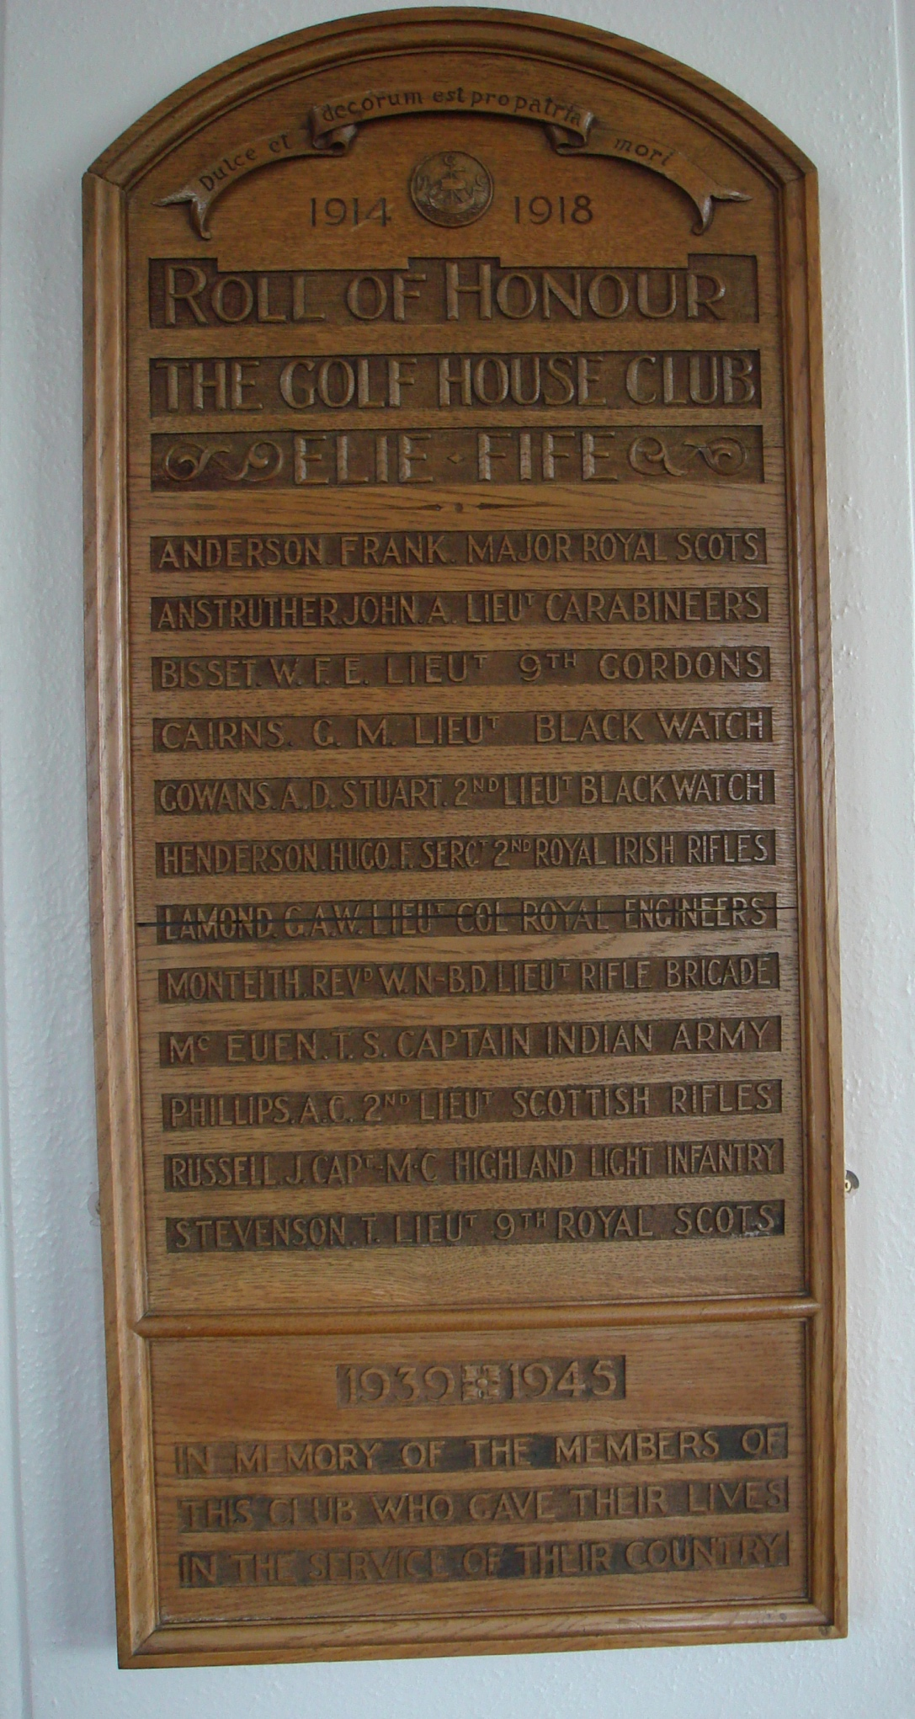

Frank Anderson.
Major. Royal Scots. 2nd Bn. (att. 12th Bn.)
d. 28 January 1917.
Remembered. Aubigny Communal Cemetery Extension, France.
Unable to confirm this is the correct soldier. No record of Elie connection.

George Morton Cairns.
Second Lieutenant. Black Watch (Royal Highlanders). 6th Bn. (T).
b. 1 September 1881 Drummond Place, Edinburgh.
Son of Henry Cairns [Writer to the Signet] and Jane Stewart Cairns.
m. September 1879 Edinburgh.
1911 Census Buckingham Terrace, Edinburgh. Law Student. Died 13 November 1916.
Remembered. Auchonvillers Military Cemetery, France.
Golf House Club, minutes Sep 04 GM Cairns [Buckingham Terrace] accepted as member GHC.

Alexander Douglas Stuart Gowans.
Lieutenant. Black Watch (Royal Highlanders). 6th Bn. (T).
b. 29 January 1896 Blantyre Terrace, Edinburgh. 1901 Census Blantyre Terrace. Son of John Stewart Gowans [Chartered Accountant] and Lizzie Jane Gowans. ms Prain. m. 1893 Edinburgh.
d. 27 April 1917.
Remembered . .Aubigny Communal Cemetery Extension, France.
Unable to confirm if this is the correct soldier. No record of Elie connection.

Hugo Fraser Henderson.
Serjeant. Royal Irish Rifles. 2nd Bn. Service No. 9388.
b. 12June 1877 Minard Terrace, Partick, Glasgow.
Son of John Lorenzo Henderson [Engineer & Iron Ship Builder] b. Valpraiso [British subject] and Elizabeth Lennox Fraser Henderson ms Fraser.
m. June 1906 Belmont Church, Hillhead, Glasgow. Ship Owner and Jane Fleming Russell.
1911 Census Hyndland Place, Glasgow. 33. Steamship Owner.
d. 15 October 1918. Aged 40. France. Killed in Action.
Remembered. Dadizeele New British Cemete1y, Belgium.
Glasgow Academy.
Unable to confirm if this is the correct soldier. No record of Elie connection.

George Alexander Walker Lamond.
Lieutenant Colonel. Royal Engineers.
b. 23 July 1878 Kelvinside, Glasgow.
Son of Robert Peel Lamond [Writer/Solicitor] and Isabella Lamond ms Jaap. m September 1866 Helensburgh. 1891 Census Rosslyn Terrace, Hillhead, Glasgow.
m. September 1911 Hillhead, Glasgow to Jean Caven Leishman.
d. 25 February 1918 Ceylon. Pneumonia. Contracted fever in Mesopotamia. Remembered. Colombo (Kanatte) Central Cemete1y, Ceylon.
Played international rugby for Scotland three times. Wales & England in 1899 and England in 1905. Scotland won all three games. Scratch golfer, played in the amateur championship St Andrews in 1913. No record of Elie connection.
James Stewart McEuen.
Captain. 20th Deccan Horse. The Indian Army. Indian national.
b. 13 September 1876.
Son of James Painter McEuen [Captain RN] and Joanne Francis Henrietta McEuen. m. July 1906 St John's Church, Edinburgh James Stewart McEuen 29 and Enid Fraser Moir 26 b. India.
d. 21 December 1914. Aged 38.
Remembered. Neuve-Chapelle Memorial, France.
Husband of Enid Fraser McEuen of Ardmore Kinnear Rd, Edinburgh. No record of Elie connection.

Arthur Cornwallis Phillips.
Second Lieutenant. Cameronians (Scottish Rifles). 1st Bn.
b. December 1896 Paddington, greater London.
Son of Herbert A Phillips [Civil Engineer] and Rosamond JM Phillips ms Cox.
m. Kensington 1895.
1901 Census. 18 Queens Gardens, Paddington.
d. 22 May 1917 aged 20.
Remembered. Sunken Road Cemetery, Boisleux-St. Marc, France.
Unable to confirm if this is the correct soldier. No record of Elie connection.

James Russell MC.
Captain. Highland Light Infantry. 17th Bn.
b. 22 November 1877. Clark Road, Glasgow.
Son of William Fleming Russell [Colliery Agent] and Robina Cook Russell ms Laing.
m. February 1877 Denny.
1901 Census Derby Cres, Glasgow. James Russell, Coal Exporter (Foreign).
d. 10 July 1917.
Remembered. Cathcart Cemetery, Glasgow.
Unable to confirm if this is the correct soldier. No record of Elie connection.

Tom Stevenson.
Lieutenant. Royal Scots (Lothian Regiment) 1st/9th Bn. (Highlanders).
b. 19 December 1890 Edinburgh.
Son of James St Clair Stevenson [Fancy Draper] and Catherine Jane Stevenson. ms Maule. m. January 1887.
1911 Census Cluny Drive, Edinburgh. 20. Draper (apprentice).
d. 1 August 1918.
Remembered. Raperie British Cemetery, Villemontoire, France.
Son of James St Clair Stevenson of 49/52 Shandwick Place, Edinburgh. Unable to confirm if this is the correct soldier. No record of Elie connection.

EARFERRY TOWN HALL

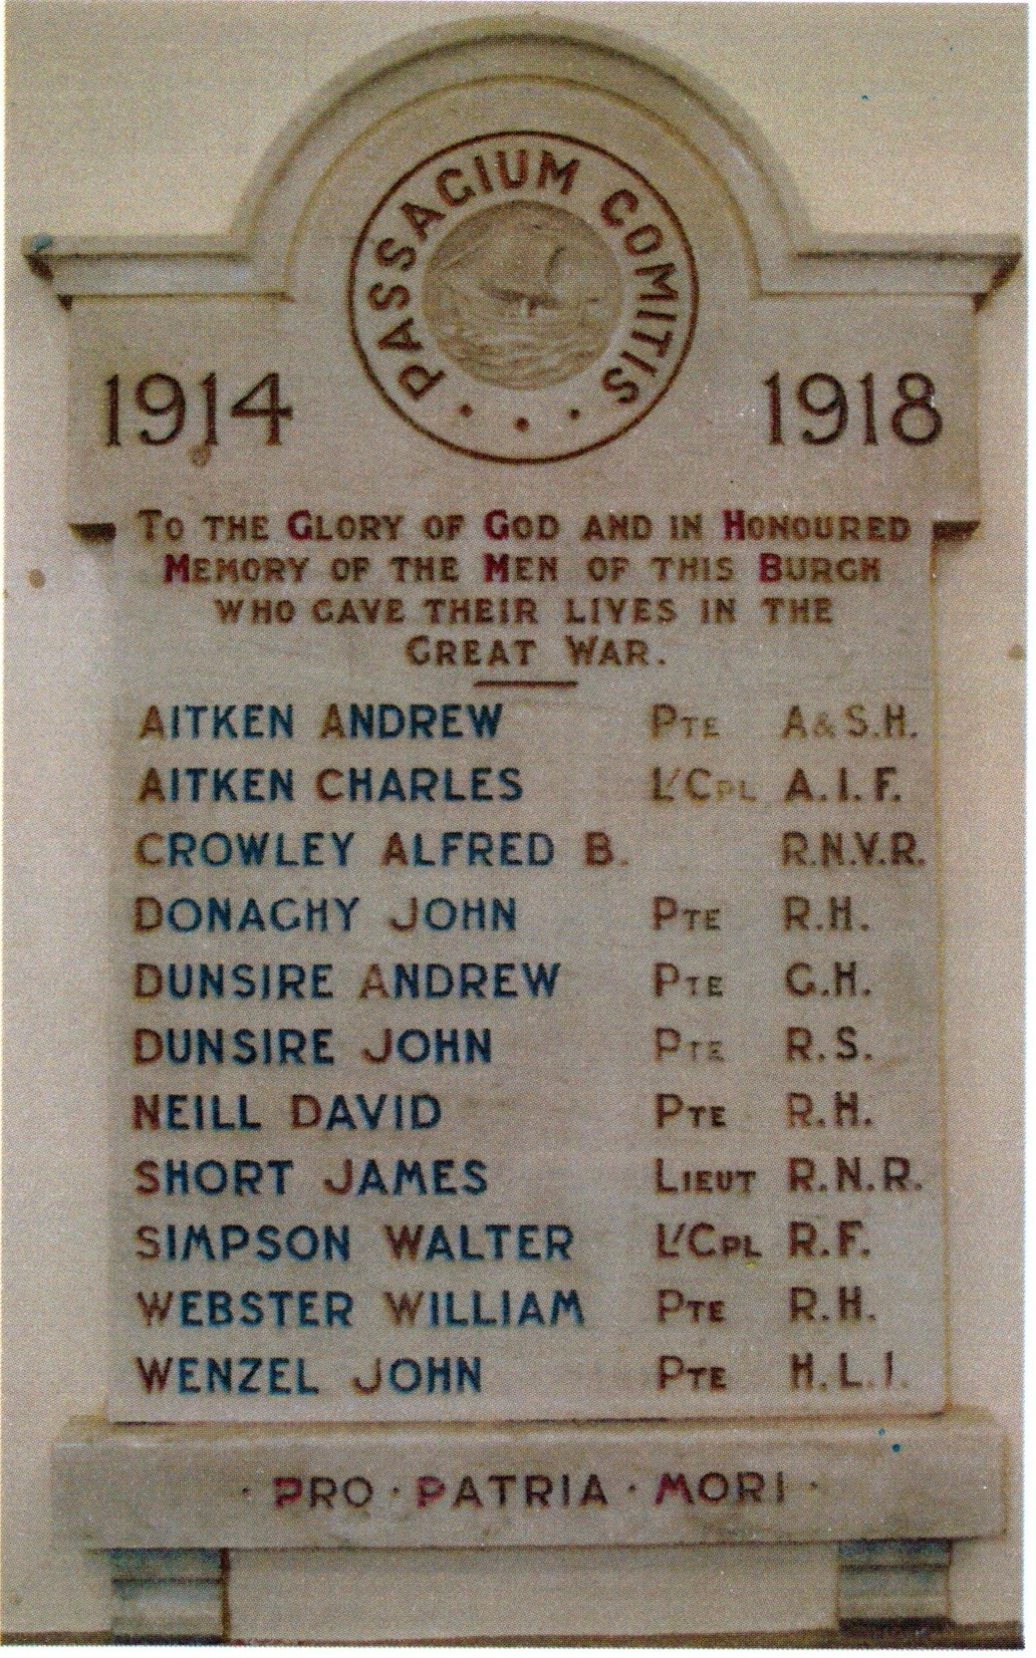

Unveiled and dedicated on Sunday 23 April 1922. Ceremony of unveiling was performed by the Rev. R.S. Armstrong, Kilconquhar Parish Church. The Hall was filled with relatives of the fallen men and representatives of various public bodies.
The Tablet is of white marble, work was executed by Mr J. Y. Thomson, Leven under
instructions from Messrs Clark & Duncan on behalf of Earlsferry Town Council.

All those named on this Tablet are also remembered on the Elie and Earlsferry War Memorial.
ELIE AND EARLSFERRY WAR MEMORIAL
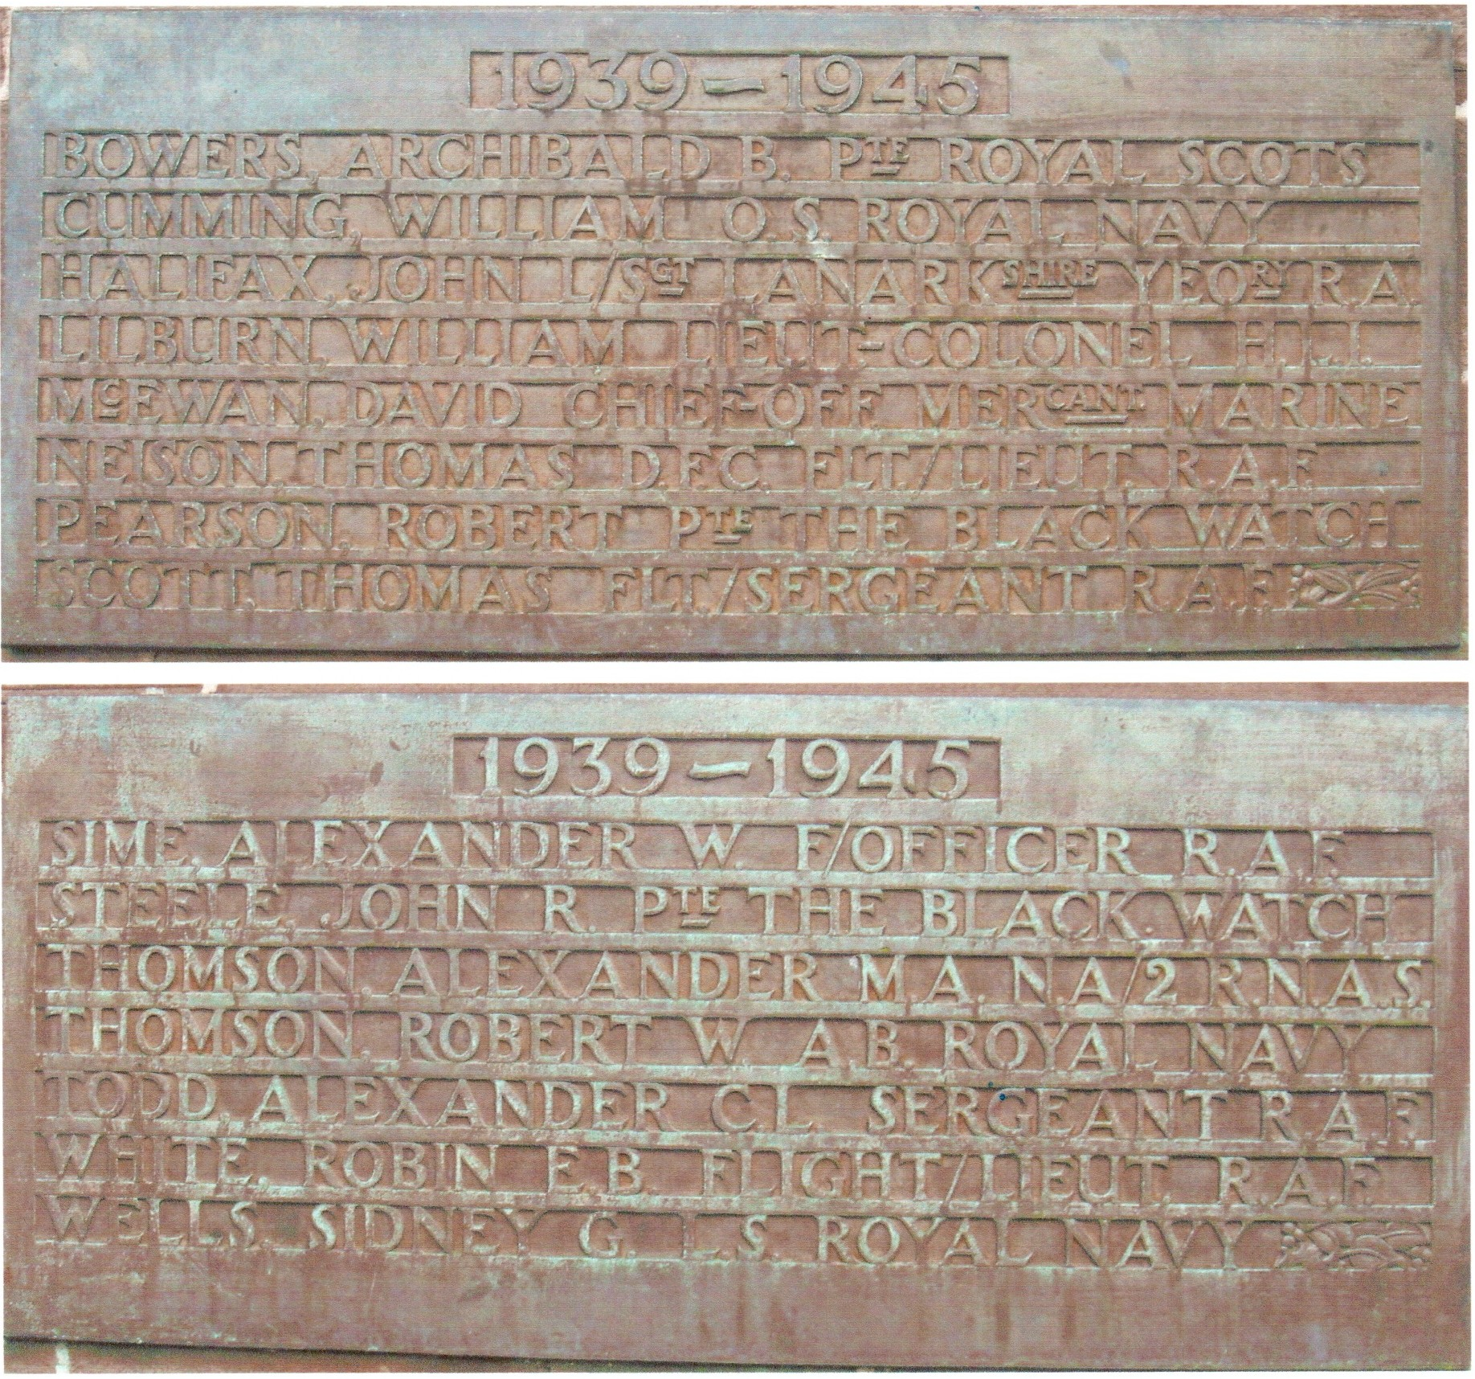
1939-1945

Dedication of Plaques Armistice Day 9th November 1947.
After a united Remembrance Day service in a well-filled Wood Memorial Church conducted by Rev. W Davidson, the vast congregation including the Town Council, British Legion, Company of Soldiers from Kincraig Camp, Army Cadets and Youth Organisations joined the congregation from the Episcopal Church at the War Memorial where Brigadier Campbell CBE, MC, TD, ADC. unveiled the two bronze panels. The Rev P.D. Gray dedicated the new plaques after which Bdr. Macrae from the camp sounded the Last Post. Wreaths were then laid by British Legion (Men's), British Legion (Women's), U.N.O., War Charities, Old Parish Church, Wood Memorial Church, Episcopal Church, The School, Army Cadets, Boy Scouts, and Girl Guides also a number of private wreaths.
The National Anthem was then sung and the Benediction given by the Rev. Lloyd Jones.

Archibald Brown Bowers.
Private. Royal Scots. (The Royal Regiment). 2nd Bn. Service No. 3061907.
b. 1 October 1914. Barnyards, Kilconquhar. Son of Esther Bowers [Domestic Servant].
Killed in Action Italy 16 September 1944. Aged 29. Remembered. Florence War Cemetery, Italy.
Obituary. East of Fife Observer 12 October 1944. Son of Esther Bowers of 9 South Street, Elie.

William Cumming.
Ordinary Seaman. Royal Navy. H.M.S. Ibis. Service No. C/JX279196.
b. 24 April 1924 St Leonards, Earlsferry.
Son of Robert Cumming and Margaret Cumming ms Aitken. m. April 1919 Earlsferry.
Lost at Sea 10 November 1942.
Remembered. Chatham Naval Memorial, England.
H.M.S. a Black Swan Class Sloop - sunk by an airborne torpedo. Obituary. East Fife Observer 10 December 1942.
Younger son of ex Provost Cumming and Mrs Cumming, St Leonards, Earlsferry.

John Halifax.
Lance Serjeant. Royal Artillery. 155 (The Lanarkshire Yeomanry) Field Regt. 318264.
b. 25 September 1911 Rockbank, Reform Street, Monifieth. Forfar.
Son of William Herbert Halifax [Hotel Manager, Panmure Hotel Monifieth] and Catherine Low Taylor Halifax ms Gregor. m. December 1905 Dundee.
m. Helen Lugton Montgomery Graham, Victoria Hotel, Elie 6 April 1937. Reside Mayview, Elie. [His parents took over ownership of the Victoria Hotel in 1919.]
Died on 20 August 1942 as a Prisoner of War in Changi Camp, Singapore. Remembered. Kranji War Cemetery, Singapore.
Obituary. East Fife Observer 3 January 1946.

William Lilburn.
Major. Highland Light Infantry (City of Glasgow Regiment). 57262.
b. 26 August 1913 8 Queens Gardens, Dowanhill, Glasgow.
Son of James Lilburn [Ship Owner] and Bethia Scott Lilburn ms Foulis.
m. June 1906 Glasgow.
Register of Electors 1930. Parents were living Craigforth, Earlsferry. Husband of Pauline Lilburn of Longframlington, Northumberland. Lived in Park Place, Elie(?)
d. 11 December 1944. Remembered. Phaleron War Cemetery, Greece.

David McEwan.
Chief Officer. Merchant Navy.
b. 20 August 1915 Main Street, Lochgelly.
Son of Andrew McEwan [Barman] and Jeanie McEwan ms Millar
m. June 1915 Main Street, Lochgelly.
Lived with his mother [father dead] in 1 Chapman's Place, Elie.
d. 3 May 1945. [local knowledge] Ship had been torpedoed - rescued but died of oil poisoning.
East Fife Observer 10 May 1945. d. At 111 North Street, Lochgelly. Son of Mrs Jean McEwan and the late Andrew McEwan, Elie.
Thomas Neison. DFC
Flight Lieutenant (Air Gnr). Royal Air Force Volunteer Reserve. 138890.
b. 23 February 1913. 261 King Street, Rutherglen. Thomas Neison.
Son of Thomas Neison and Annie Neison ms Stannage m. May 1912 Stirling.
m. Helen Watson 24 November 1933 Rutherglen. Thomas Neison (widower).
m. Christina McGregor 16 April 1941 Edinburgh. Alister Thomas McKenzie Neison. April 1944. London Gazette. “Flight Lieutenant Neison defended his aircraft with much skill and finally struck the enemy aircraft causing it to explode in the air”. Distinguished Flying Cross.
d. 22 June 1944. mid upper air gunner on Lancaster Bomber No. ME 843 - took off from RAF East Kirkby- raid on Wesseling, Germany- shot down by a night fighter - all seven occupants all members of 630 Squadron were killed in crash.
Remembered. Heverlee War Cemetery, Belgium. Christina Neison living at 53 High Street, Elie.

Robert Pearson.
Bandsman. The Black Watch (Royal Highland Regiment) 1st Bn. 2752611.
b. 20 May 1914 8 School Wynd, Elie.
Son of George Pearson [Postboy] and Joanie Pearson m. February 1909 Elie.
d. 25 December 1940.
Remembered. Malbork Commonwealth War Cemetery, Poland. Register of Electors 1930. Parents in Kirkpark Road.
East Fife Record 20 February 1941. Elie man dies in prison camp on Christmas day 6 months after becoming a prisoner.
Son of Mr & Mrs George Pearson, Laburnum Grove, Back Dykes, Elie.
He and his brother George, also bandsman with 1st Bn. Black Watch, both captured near St Valery on 16 June.

Thomas Ireland Scott.
Sergeant. Royal Air Force Volunteer Reserve. 100 Squadron. 1823365. Son of Andrew Hutchison Scott and Beatrice Mackie Scott.
Killed in Action 19 July 1944. Scholven, Germany. Air Ops. Aged 19.
50 Woodside Road, Elie. Eldest son of Beatrice M Scott and the late Andrew H Scott.
East Fife Record 18 July 1946. In Memory, and the crew of their bomber who lost their lives on 19 July 1944. All interred at East Hullen, Gelsenkirchen, Germany.
Remembered Reichswald Forest War Cemetery, Germany.

Alexander William Sime.
Flying Officer. Royal Air Force Volunteer Reserve. 38 Squadron. 162217.
b. 6 October 1918 1 Church Lane, Elie.
Son of William Ovenstone Sime [Domestic Servant, Discharged Merchant Seaman] and Margaret-Ann Sime ms Ross. m. September 1912. Grantown-on-Spey.
d. 20 March 1945. Remembered Malta Memorial, Malta. Aged 25.
East Fife Observer. 20 November 1945. Is presumed to have lost his life in operations on 20 March 1945 over North Italy.

John Ritchie Steele.
Private. Black Watch (Royal Highlanders) 7th Bn. 2766984.
b. 11 February 1914 Bonaccord Street, Clydebank.
Son of James Steele [ships caulker] and Margaret Whitelaw Steele ms Ritchie.
m. December 1901 Alexandria.
d. 23 October 1942. Remembered. El Alamein War Cemetery, Egypt. Aged 28.
East Fife Observer 19 November 1942. Son of Mr & Mrs J Steele, 6 Pilmuir Place, St Andrews and beloved brother of Mrs MB Wood, Chemist, 42 High Street, Elie.

Alexander Malcolm Arthur Thomson.
Naval airman 2nd Class. Royal Navy. FAA/FX 9233. H.M.S. Dasher.
b. 11 May 1922 the Toft, Elie.
Son of John Warrender Thomson [Fisherman] and Sarah Jane Thomson ms Mudie.
m. June 1908 Leith.
d. 27 March 1943. Remembered. Lee-on-Solent Memorial. Aged 20.
HMS Dasher. Converted Merchant Vessel to Aircraft Carrier. Firth of Clyde, on exercise, major internal explosion and sunk. 379 crew members lost.
[See 4 books written by John Steele and Noreen Steele for the full story of this disaster.]
East Fife Observer. 8 April 1943. Missing in Action
East Fife Observer 6 May 1943. Killed in Action. Mr & Mrs John Thomson The Toft, Elie.
Related to Robert Warrender Thomson.

Robert Warrender Thomson.
Able Seaman. Royal Navy. C/JX373084. H.M.S. Boadicea.
b. 19 July 1923 High Street, Earlsferry.
Son of Thomas William Dent Bonner Thomson [Shoemaker] and Grace Archibald Thomson ms MacLaren. m. March 1914 Milnathort.
Lost at Sea 13 June 1944. HMS Boadicea (H65) B Class Destroyer. Aged 20. Boadicea was sunk on 13 June 1944 escorting Convoy EBC-8 in support of the Normandy Invasion.
Remembered. Chatham Naval Memorial, England. East Fife Observer 17 August 1944.
Only son of Mr & Mrs TB Thomson, Seafield Bank, The Toft, Elie. Related to Alexander M A Thomson.

Alexander Crew Lachie Todd.
Sergeant. Royal Air Force Volunteer Reserve. 78 Squadron. 1554137.
b. 7 May 1921 Milton Street, Edinburgh.
Son of Walter Todd [Paper Ruler] and Jeanie Todd ms Leckie.
m. April 1913 Edinburgh.
d. 6 October 1944. Gahlen, Besten, Germany. Air Ops. Aged 22. Remembered. Reichswald Forest War Cemetery, Germany.
East Fife Observer 22 November 1945. Mother. Jean Todd of Sunterville, Earlsferry.

Sydney George Wells.
Leading Seaman. Royal Navy. P /JX137695. H.M.S. Pylades.
Son of Henry and Elizabeth Wells. Husband of Patricia Wells of Washington, Co. Durham.
Lost at Sea 8 July 1944. Remembered Portsmouth Naval Memorial, England. Aged 28. HMS Pylades. Minesweeper was hit by 2 German “Neger” human torpedoes off Normandy. Ship sunk. 11 men lost.
East Fife Observer 14 June 1945. Family at 14 Woodside Crescent, Elie.

Robin Eustace Brittain White.
Flight Lieutenant. Royal Air Force. 28 Squadron. 41228.
Son of Eustace Evans White [Journalist] and Nora Brittain White of Earlsferry.
Killed in Action 27 July 1942.
Remembered. Karachi War Cemetery, Pakistan. Aged 27.
East Fife Observer 27 August 1942. Killed operational flight in India.
Mrs Eustace White with her mother Mrs Foster, The Gable, Earlsferry. Robin White was Palestine Police 1938-39.
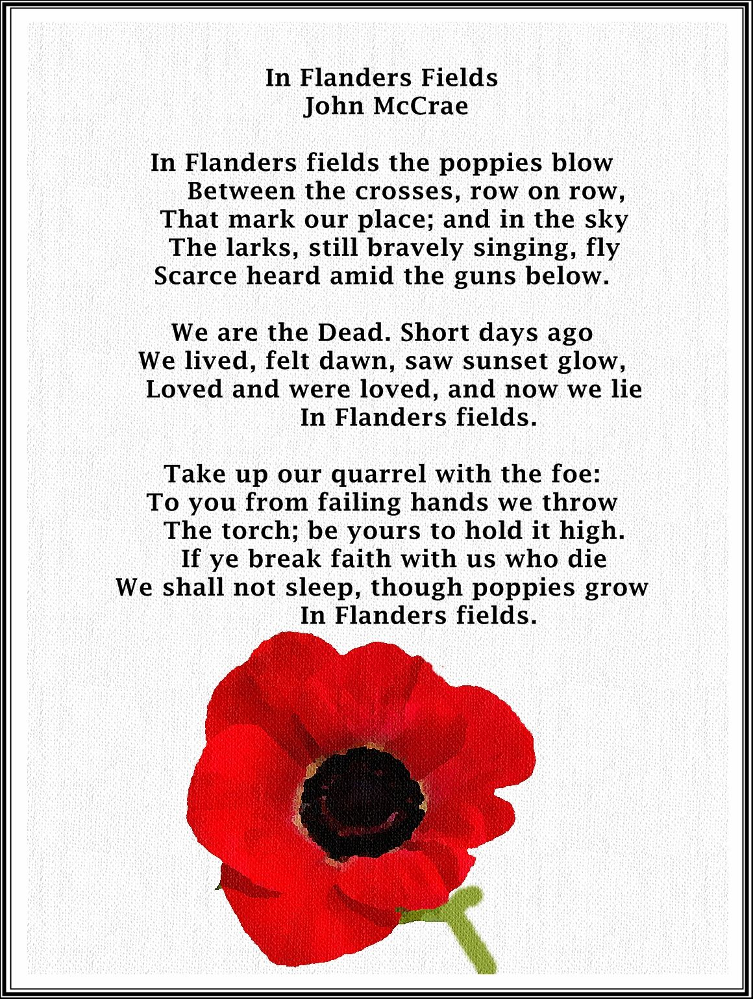

Acknowledgements and further reading:

www.eliewarmemorials.org.uk
www.scotlandspeople.gov.uk
www.ancestry.co.uk
www.snwm.org.uk
www.cwgc.org.uk
www.1914-1918.net

Elie Library
East Fife Record
East Fife Observer
Elie Parish Church
Golf House Club, Elie
Elie Kirk by David Thomson St Andrews University Library
Heritage and Hope by Stuart George Hall.

